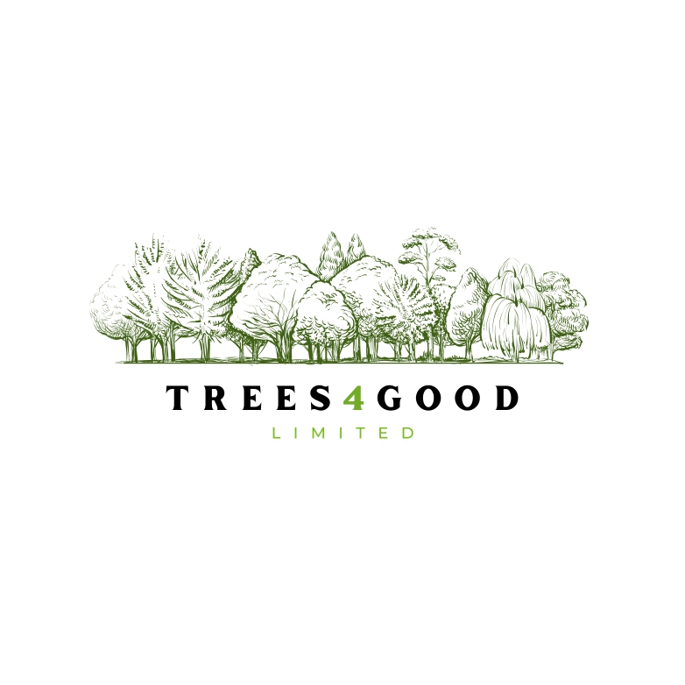
Risk Factors

Risk Factors
This summary informs intending Subscribers for Convertible Redeemable Preference Shares (CRPS) in Trees4Good (T4G) are aware of the risks associated with such an investment.
T4G only provides information and its interpretation of same. T4G does not give advice regarding the suitability of any investment to any third party. Where figures, alternatives, or outcomes are shown or described, these are for illustration only and must not be relied upon.
References to sources of material, weblinks, or websites were correct at date of issue. T4G cannot be responsible for any changes to access conditions, accuracy of content, or amendments made by any source.
CRPS are issued by a private company with ultimate liability limited by Ordinary Shares, any cash holdings, and any net assets available. CRPS will not be traded on any exchange, and it is very unlikely that a market, private or otherwise, will be made for them.
Therefore, CRPS should be considered as highly illiquid.
The underlying business may offer some asset value subject to market fluctuations, operating conditions and demand for land, amenity, and types of timber from time to time.
There may be no readily realisable market value for the CRPS and investors should assume they may be unable to sell them at any price.
Forestry, by its very nature involves significant risk. Whilst Forestry investments are exposed to biological, environmental, commercial and regulatory risks. high returns are possible, and the underlying land will have some (residual) value, no guarantees of success can be offered to investors. Whilst demand for timber has been, and currently is, buoyant, this cannot be guaranteed in the future. It’s use for many applications is expanding. Good planting, maintenance, recovery, as well as good location, experience and knowledge are essential.
Management intends to manage losses and risks, and exploit to the maximum positives and opportunities balanced against any risk factors. Despite this, there are external factors beyond the control of management, E.g. Windblow, Government Policy.
To maximize returns T4G will seek to broaden the cash take through thinning, leisure and sporting, E.g. Firewood, hiking/trails/ponds and sporting.
Where possible (E.g. Part sale of larger holding) and at the earliest opportunity, T4G will seek to underpin the CRPS with a high quality credit instrument and (any) coupons attached.

Investment in CRPS involves significant risk including.
The value of the Company's business may be affected by matters including:
- timber prices;
- forestry values;
- land values;
- environmental conditions;
- disease;
- fire;
- wind and storm damage;
- climate;
- government policy;
- regulation;
- taxation;
- grant availability;
- planning;
- operating costs;
- management performance;
- access to finance; and
- general economic conditions.
There is no guarantee that T4G will generate sufficient profits to make any Distribution.
A CRPS Holder may receive substantially less than the Maximum Distribution Amount

TAX ASPECTS
T4G holds no professional tax qualifications and cannot advise upon taxation.
It is the responsibility of the CRPS subscriber to be satisfied with a CRPS purchase being suitable, acceptable and within risk tolerances for the purpose of fulfilling objectives sought. T4G supply references to websites which supply formal information and advice, T4G cannot be responsible for any errors or omissions contained therein, e.g. HMRC.

