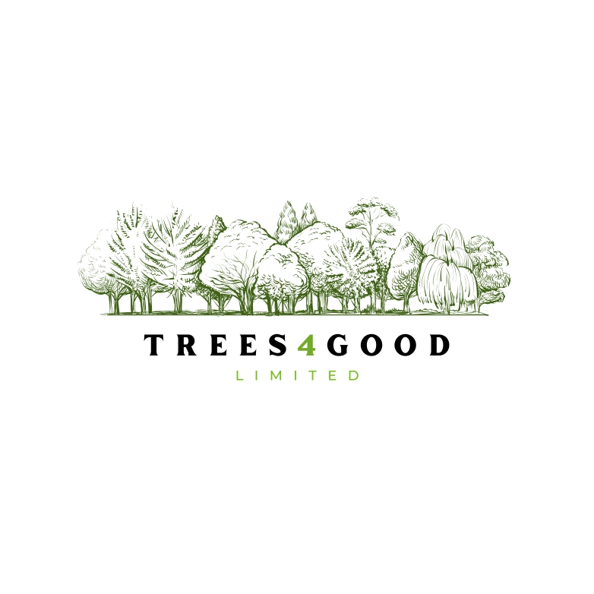

Policies and Procedures

FORESTRY IN UK
The (re)forestation of the UK is seen as good thing; it attracts a lot of charitable interest and support, most notably from the Woodland Trust and the Forestry Commission. There is Governmental support through planning, grants, and favourable tax treatments.
A huge amount of data is available, this is supported by detailed historical facts and comment. T4G will use all available data, professional opinion, and market knowledge to ascertain the worth and future potential of all purchases,
There is a great deal of forestry for sale – in small to large amounts and values, is UK wide (centred Scotland in volume), has established industry infrastructure, and Govt. interest through the Forestry Commission – FC – the last produce industry Standard figures, results, scientific works, and empirical studies.
Planting has been mixed over last 40 years – 10-20% Broad Leaf, BL, and 80-90% Soft Wood Conifer Timber, SWCT. This is changing in favour of BL as Govt, emphasis and grants increase for BL, and charities are keen to replant only with native BL. Nevertheless, Sitka Spruce remains the most popular choice representing 50% of all planting. A great deal of information and policy is available from FC and Woodland Trust.
There is greater amount of Govt. (and charity) interest in replanting with native species – broadleaf or deciduous, however, conifers still attract some funding, and remain the preferred, harvested commercial crop.
Revenue streams from forestry are recognised as being under exploited, E.g. Leisure, trekking, walking, sporting, outdoor events/course. This especially true of the larger estates, although some are remote and hard to get around.
Maintenance costs will exist until approximately year 20 decreasing from n0.. except for wind blow and disease control. Note that during this period, some offset from income will arise from thinning and wind blow.
Real value/income should start around year 20, peak values around years 35-46.
There are few negative aspects to tree planting, (opportunity costs of lost food production), the current assistance, grant, and infrastructure available has no obvious or declared barriers or curtailment.
Grants are mainly unavailable for reforestation of existing/previous plantations - exceptions deal with replanting of conifer with broad leaf trees – especially native species. The focus is upon ‘new’ land which was previously used for other purposes – reclaimed land in urban areas attracts numerous additional grants to planting funds alone – more typically, farmland, or expanding existing parkland would be good examples.

Depending upon the amount of funds available through CRPS subscription, and the time taken for same, the first six months will be used to complete establishment including contacts and connections to move the Company forward.
Acquisitions will be made by Private Treaty, Auctions, Share Purchase. In all cases, full sale and transfer particulars, financial records, and title documents will be kept by the Company.
Acquisitions will continue, but focus will spread to development – including planning -, (re)sales possibilities, and, if possible, early (thinning) and non-timber (leisure) income.
NEED FOR CAPITAL
All businesses need working capital, T4G will be able to commence trading with little or no need for Capital or Fixed Cost expenditure. Thus, the vast majority of funds received will be committed towards expenditure directly related to providing a return to HCRPS. Unless there is sufficient income to cover costs, the Company does not intend to borrow to acquire.
MANAGEMENT POST ACQUISITION -
Forestry acquisitions frequently come with advisers and staff intact. T4G intends to retain these services where successful; particularly where logging infrastructure is present. At a certain point, and assuming sufficient expansion has occurred, it is likely a third-party organisation will be engaged to manage and maximize the non-timber revenue potential.
FORESTRY ASPECTS – FELLING, RECOVERY, POST RECOVERY/INITIAL PLANTING
It is typical for a forestry estate to be bought with a varying degree of tree species, maturity, (any) remaining grants, shared access, shared responsibility for maintenance of the forests (fire breaks, paths, roads and tracks), and to partake in shared recovery of own and third party owned timber contemporaneously – the last due to the restricted capacity of available specialized equipment, and that of saw mills.
CRPS – STRUCTURE & LIMITS
- Profit only shares issued to raise new capital from inward capital contributors – subscribers - and offer a non-guaranteed return of a multiple of their subscription(s).

- CRPS have no voting rights or other influence upon T4G strategy, or operation of the business conducted or contemplated, save for clear and deliberate misuse of contributed funds under the Operating Agreement.

- CRPS have a time limit of 10 calendar years from date of issue, + time to the end of that trading year of the Company where the 10 years have elapsed. They may be converted to Ordinary Shares as a no cost option – see below.

- CRPS have a fixed price in £GBP only of £1.00GBP at all times.

- The returns on CRPS will be by dividend distribution only in cash unless otherwise mutually agreed. CRPS have no rights to any guaranteed payments, and dividends will not be paid unless sufficient profits are made by T4G – see 4. CRPS Terms & Conditions below.

- CRPS will be fully redeemed once T4G has paid a multiple of 3x (three times) the par subscription price paid by the subscriber no other benefits/distributions will be due.

- CRPS are fully transferrable, assignable, or may be sold to any third-party willing buyer.

- T4G reserves the right to offer different terms of return to subsequent subscribers. Where such terms offer a superior return, whether in quantum or time or distribution weight (see below), these terms will be applied to existing CRPS holdings.

- Where the word ‘subscriber’ or ‘contributor’ is used, this also refers to any holder of CRPS from time to time, E.g. A transferee. Where the word ‘distribution’ is used, this always means dividend distribution made under the CRPS Terms & Conditions.

- CRPS are not cumulative – see 4.f below.

- CRPS will be issued electronically and in hard copy format.
l. Conversion of CRPS – This no cost option will be made available to CRPS holders at the end of year 10 from issue date. The CRPS holder will be supplied with a set of unaudited accounts in T4G 180 days prior to CRPS expiry, the holder will have 110 days to exercise the option to convert their CRPS holding to Ordinary shares in T4G using the form supplied if desired.
This option will not be available if T4G has redeemed the CRPS under the purchase agreement - this is returning 3x (three times) times the par price of the CRPS through dividends and/or (part) sales of the assets or Ordinary Shares
Conversion is at the sole election of the HCRPS, the Company has no right to enforce any conversion or deny same.
The HCRPS may convert all, some, or none at all. Once converted, the shares will be Ordinary, and carry all rights as existing Ordinary Shares issued from time to time.

4. CRPS TERMS & CONDITIONS OF PURCHASE & ISSUE -

- Only UK citizens, or others deemed domiciled and resident in UK for tax purposes may subscribe for CRPS. Applications from commercial entities will not be accepted.

- All subscriptions must be made to T4G in £GBP through a bank with a UK Sort Code.

- All Subscribers must be 18 years old at time of application.

- Any dividend distributions will arise from profits made by T4G – see e. & h. below.

- Profits available for distribution are defined as Turnover in a trading year of T4G, less trading expenses down to EBITDA + 10%. Any remaining profits will be distributed as a dividend weighted in favour of the CRPS subscriber – [80%] to subscriber, [20%] to T4G.
Note that the split is calculated from any funds remaining, thus, the subscriber is not paid first but more only.
- There is no carry back/forward to previous/future T4G trading years in the event there is no distribution to subscribers in any previous trading year(s) – noncumulative.

- All dividend distributions must be used to make the CRPS holding fully paid up before any distribution can be made to a subscriber direct.

- As well as e above, all inward amounts to T4G, except for debt or investments, will be counted towards a distribution, E.g. A (part) buy out of T4G.

- T4G has no powers to make the subscriber sell back to T4G any of the CRPS held.

- All subscriptions, distributions, or buy back will be in cash only unless otherwise mutually agreed. no further distributions will be due once CRPS redemption is complete.

5. SUBSCRIBER CASH CALL CONDITIONS
T4G reserves the right to demand the subscriber, or subsequent holder of CRPS, make cash contribution(s) to make the CRPS held fully paid up under any one of the conditions below. This right protects the Company’s plans, and the other investors.
Any cash call demanded by T4G is subject to any of the points below -
- Death of subscriber, or, where jointly held, first death of joint holders of CRPS.

- Transfer of Subscriber’s affairs to the Court of Protection or similar.

- Subscriber is subject of a Statutory Demand, Civil Court action for money or money’s worth, Bankruptcy, or any award for money against subscriber of any kind, save child maintenance or a motoring fine.

- Subscriber wishes to transfer CRPS to discharge a debt, or obligate CRPS in any way.

- Subscriber wishes to offer CRPS to replace or decease existing assets under any debt collateral position.

- Subscriber receives a criminal sentence of 6 months or more, whether suspended or not, or Subscriber receives a criminal conviction involving money or money’s worth at any time for any reason.

- Where CRPS are jointly held, the above applies to any remaining CRPS holder.

- A cash call, excepting Probate, must be paid by HCRPS within 30 calendar days.
LIMITS OF RETURN TO CRPS
- The maximum return to CRPS is three times the par £1.00 issue price

- CRPS expire without (future) value once their 10-year term plus any remaining time to the end of the trading year of expiry is reached – No return is guaranteed.

- Cash Call conditions exist – see 5 above - until CRPS are fully paid up to par at £1.00.

- No direct distribution for cash will be made until CRPS are fully paid up.

- CRPS are profit participation only, they do not have any voting rights and may only if T4G makes a profit as described above.

- Distributions will be subject to tax assessment from time to time. It is entirely the subscriber’s own responsibility to agree matters with HMRC.
7. RISK FACTORS –
CRPS are issued by a private company with ultimate liability limited by Ordinary Shares, any cash holdings, and any net assets available. CRPS will not be traded on any exchange, and it is very unlikely that a market, private or otherwise, will be made for them.
THEREFORE, CRPS SHOULD BE CONSIDERED AS HIGHLY ILLIQUID.
The underlying business may offer some asset value subject to market fluctuations, operating conditions, and demand for land, amenity, and types of timber from time to time.
NOTE: CRPS are likely to have a zero to very low value in the early years after subscription and may never reach par value.
Forestry – By its very nature involves significant risk. Whilst high returns are possible, and the underlying land will have some (residual) value no guarantees of success can be offered to investors. Whilst demand for timber has been, and currently is, buoyant, this cannot be guaranteed in the future. Its use for many applications is expanding. If comparisons can be made, forestry is around 7-9 on a TRL Scale of risk versus reward (out of 12). Good planting, maintenance, recovery, as well as suitable location, experience and knowledge are essential.
It is up to management to mitigate losses and risks and exploit to the maximum positives and opportunities balanced against any risk factors. Despite this, there are external factors beyond the control of management, E.g. Windblow, Government Policy.
OTHER RISK FACTORS -
- CRPS are highly illiquid and time limited through convertible preference shares.

- They may not acquire any value at any time or receive any distribution.

- Distributions will be subject to UK taxation; and will be in cash & £GBP only.

- T4G is a private company and may find financing more difficult to acquire, and at more expensive rate/costs, than larger publicly quoted Companies.

- CRPS have no participation in the planning, strategy, or decision making within T4G.

- It is highly unlikely any market will exist or be made for CRPS.
- T4G is a small company – SME – and, as such, will be less able to withstand adverse changes in trading conditions than larger companies.

- Changes in legislation may adversely affect the profitability of T4G.

- Non-cumulative -see 4f above.
To maximize returns, T4G will seek to broaden the cash take through thinning, leisure, and sporting, E.g. Firewood, hiking/trails/ponds and wildlife.

